CERTIFICATION OF ENROLLMENT
INITIATIVE 1634
Chapter 2, Laws of 2019
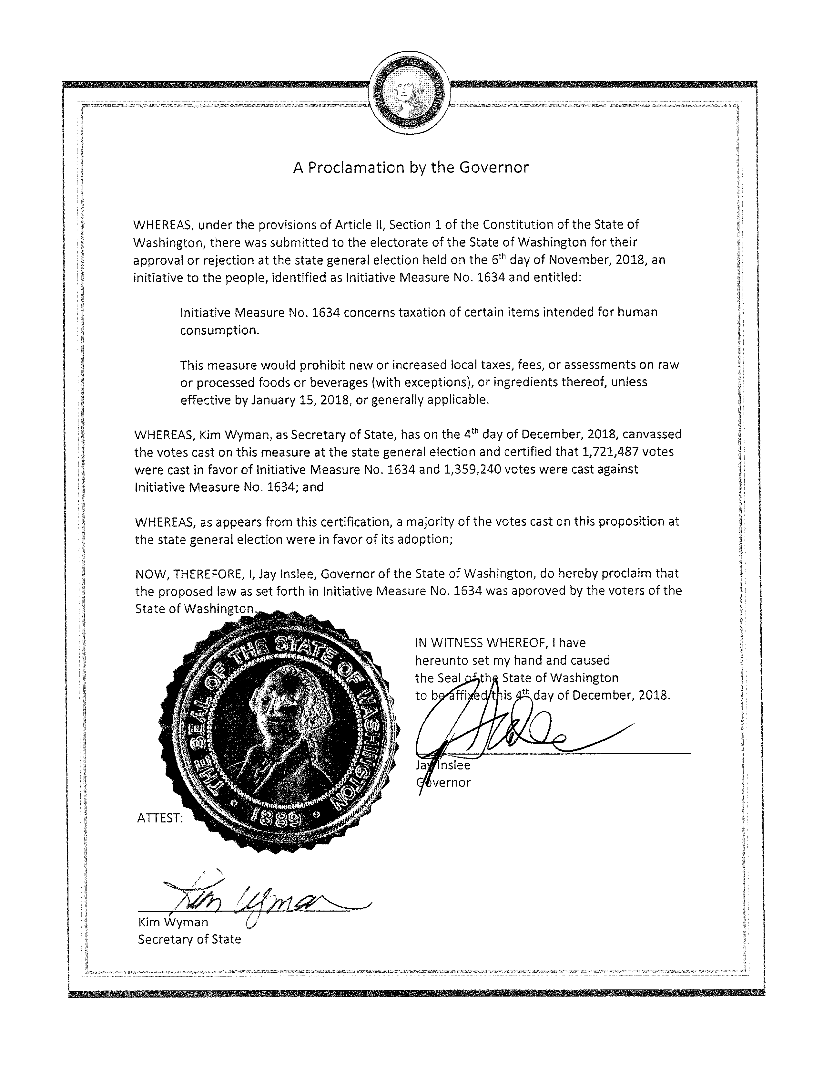
66th

LOCAL GOVERNMENT TAXATION OF FOODS AND BEVERAGES
EFFECTIVE DATE: December 6, 2018
Approved by the  People of the State of Washington  in the General Election on  Approved November 6, 2018 | ORIGINALLY FILED  March 26, 2018  Secretary of State

_______________________________________________

INITIATIVE 1634
_______________________________________________

State of Washington 66th 2019 Regular Session

By

AN ACT Relating to the taxation of groceries; and adding a new chapter to Title 82 RCW.

BE IT ENACTED BY THE PEOPLE OF THE STATE OF WASHINGTON:
NEW SECTION. Sec. SHORT TITLE. This chapter may be known and cited as the "keep groceries affordable act of 2018."
NEW SECTION. Sec. KEEPING GROCERIES AFFORDABLE: FINDINGS AND DECLARATIONS. (1) Whereas access to food is a basic human need of every Washingtonian; and
(2) Whereas keeping the price of groceries as low as possible improves the access to food for all Washingtonians; and
(3) Whereas taxing groceries is regressive and hurts low- and fixed-income Washingtonians the most; and
(4) Whereas working families in Washington pay a greater share of their family income in state and local taxes than their wealthier counterparts; now, therefore,
(5) The people of the state of Washington find and declare that no local governmental entity may impose any new tax, fee, or other assessment that targets grocery items.
NEW SECTION. Sec. DEFINITIONS. For purposes of this chapter:
(1) "Alcoholic beverages" has the same meaning as provided in RCW 82.08.0293.
(2) "Groceries" means any raw or processed food or beverage, or any ingredient thereof, intended for human consumption except alcoholic beverages, marijuana products, and tobacco. "Groceries" includes, but is not limited to, meat, poultry, fish, fruits, vegetables, grains, bread, milk, cheese and other dairy products, nonalcoholic beverages, kombucha with less than 0.5% alcohol by volume, condiments, spices, cereals, seasonings, leavening agents, eggs, cocoa, teas, and coffees whether raw or processed.
(3) "Local governmental entity" has the same meaning as provided in RCW 4.96.010.
(4) "Marijuana products" has the same meaning as provided in RCW 69.50.101.
(5) "Tax, fee, or other assessment on groceries" includes, but is not limited to, a sales tax, gross receipts tax, business and occupation tax, business license tax, excise tax, privilege tax, or any other similar levy, charge, or exaction of any kind on groceries or the manufacture, distribution, sale, possession, ownership, transfer, transportation, container, use, or consumption thereof.
(6) "Tobacco" has the same meaning as provided in RCW 82.08.0293.
NEW SECTION. Sec. KEEPING GROCERIES TAX FREE—PROTECTING TRADITIONAL LOCAL REVENUE STREAMS—CONTINUED AUTHORITY. Notwithstanding any other law to the contrary:
(1) Except as provided in subsections (2) through (4) of this section, a local governmental entity may not impose or collect any tax, fee, or other assessment on groceries.
(2) Nothing in this section precludes the continued collection of any existing tax, fee, or other assessment on groceries as is in effect as of January 15, 2018; but no existing tax, fee, or other assessment on groceries may be increased in rate, scope, base, or otherwise after January 15, 2018, except as provided in subsections (3) and (4) of this section.
(3) Nothing in this section prohibits the imposition and collection of a tax, fee, or other assessment on groceries if:
(a) The tax, fee, or other assessment is generally applicable to a broad range of businesses and business activity; and
(b) The tax, fee, or other assessment does not establish or rely on a classification related to or involving groceries or a subset of groceries for purposes of establishing or otherwise resulting in a higher tax rate due to such classification.
(4) Nothing in this section prohibits the imposition and collection of a local retail sales and use tax pursuant to RCW 82.14.030 on those persons taxable by the state under chapters 82.08 and 82.12 RCW.
NEW SECTION. Sec. IMPLEMENTATION. Notwithstanding any other law to the contrary:
(1) This chapter applies to any tax, fee, or other assessment on groceries first imposed, increased, or collected by a local governmental entity on or after January 15, 2018.
(2) The provisions of this chapter are to be construed liberally so as to effectuate their intent, policy, and purposes.
NEW SECTION. Sec. SEVERABILITY. (1) If any provision of this act or its application to any person or circumstance is held invalid, the remainder of the act or the application of the provision to other persons or circumstances is not affected.
(2) The people of the state of Washington hereby declare that they would have adopted this chapter, and each and every portion, section, subsection, clause, sentence, phrase, word, and application not declared invalid or unconstitutional without regard to whether any portion of this chapter, or application thereof, would be subsequently declared invalid.
NEW SECTION. Sec. Sections 1 through 5 of this act constitute a new chapter in Title 82 RCW.

--- END ---

