CERTIFICATION OF ENROLLMENT
INITIATIVE 940
Chapter 1, Laws of 2019
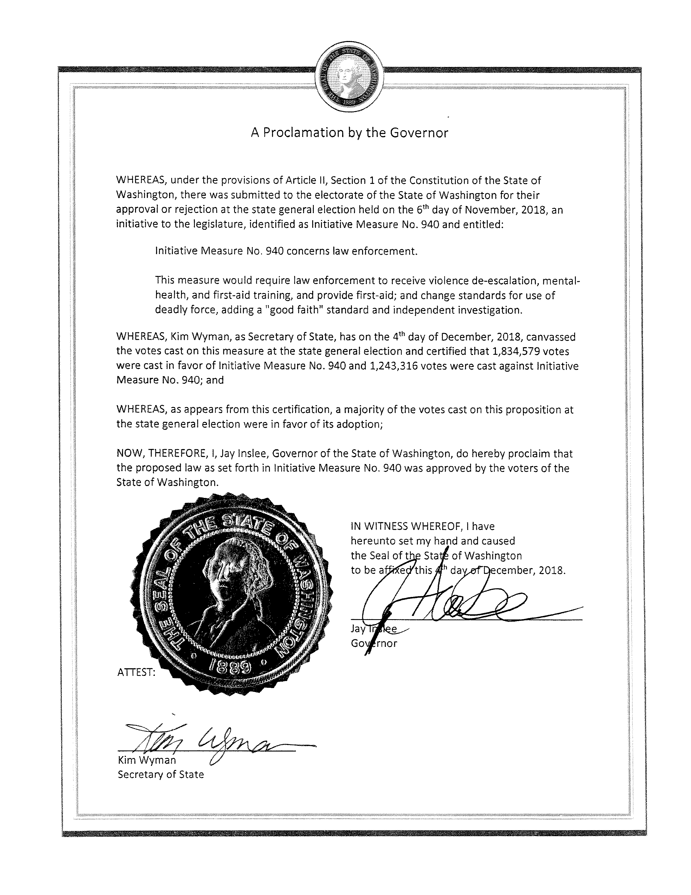
66th

LAW ENFORCEMENT—DEADLY FORCE—TRAINING
EFFECTIVE DATE: December 6, 2018
Approved by the  People of the State of Washington  in the General Election on  Approved November 6, 2018 | ORIGINALLY FILED  May 23, 2017  Secretary of State

_______________________________________________

INITIATIVE 940
_______________________________________________

State of Washington 66th 2019 Regular Session

By

AN ACT Relating to law enforcement; amending RCW 9A.16.040; adding new sections to chapter 43.101 RCW; adding new sections to chapter 36.28A RCW; and creating new sections.

BE IT ENACTED BY THE PEOPLE OF THE STATE OF WASHINGTON:
PART I
TITLE AND INTENT
NEW SECTION. Sec. This act may be known and cited as the law enforcement training and community safety act.
NEW SECTION. Sec. The intent of the people in enacting this act is to make our communities safer. This is accomplished by requiring law enforcement officers to obtain violence de-escalation and mental health training, so that officers will have greater skills to resolve conflicts without the use of physical or deadly force. Law enforcement officers will receive first aid training and be required to render first aid, which will save lives and be a positive point of contact between law enforcement officers and community members to increase trust and reduce conflicts. Finally, the initiative adopts a "good faith" standard for officer criminal liability in those exceptional circumstances where deadly force is used, so that officers using deadly force in carrying out their duties in good faith will not face prosecution.
PART II
REQUIRING LAW ENFORCEMENT OFFICERS TO RECEIVE VIOLENCE DE-ESCALATION TRAINING
NEW SECTION. Sec. A new section is added to chapter 43.101 RCW to read as follows:
(1) Beginning one year after the effective date of this section, all law enforcement officers in the state of Washington must receive violence de-escalation training. Law enforcement officers beginning employment after the effective date of this section must successfully complete such training within the first fifteen months of employment. The commission shall set the date by which other law enforcement officers must successfully complete such training.
(2) All law enforcement officers shall periodically receive continuing violence de-escalation training to practice their skills, update their knowledge and training, and learn about new legal requirements and violence de-escalation strategies.
(3) The commission shall set training requirements through the procedures in section 5 of this act.
PART III
REQUIRING LAW ENFORCEMENT OFFICERS TO RECEIVE MENTAL HEALTH TRAINING
NEW SECTION. Sec. A new section is added to chapter 43.101 RCW to read as follows:
(1) Beginning one year after the effective date of this section, all law enforcement officers in the state of Washington must receive mental health training. Law enforcement officers beginning employment after the effective date of this section must successfully complete such training within the first fifteen months of employment. The commission shall set the date by which other law enforcement officers must successfully complete such training.
(2) All law enforcement officers shall periodically receive continuing mental health training to update their knowledge about mental health issues and associated legal requirements, and to update and practice skills for interacting with people with mental health issues.
(3) The commission shall set training requirements through the procedures in section 5 of this act.
PART IV
TRAINING REQUIREMENTS SHALL BE SET IN CONSULTATION WITH LAW ENFORCEMENT AND COMMUNITY STAKEHOLDERS
NEW SECTION. Sec. A new section is added to chapter 43.101 RCW to read as follows:
(1) Within six months after the effective date of this section, the commission must consult with law enforcement agencies and community stakeholders and adopt rules for carrying out the training requirements of sections 3 and 4 of this act. Such rules must, at a minimum:
(a) Adopt training hour requirements and curriculum for initial violence de-escalation trainings required by this act;
(b) Adopt training hour requirements and curriculum for initial mental health trainings required by this act, which may include all or part of the mental health training curricula established under RCW 43.101.227 and 43.101.427;
(c) Adopt training hour requirements and curricula for continuing trainings required by this act;
(d) Establish means by which law enforcement officers will receive trainings required by this act; and
(e) Require compliance with this act's training requirements as a condition of maintaining certification.
(2) In developing curricula, the commission shall consider inclusion of the following:
(a) De-escalation in patrol tactics and interpersonal communication training, including tactical methods that use time, distance, cover, and concealment, to avoid escalating situations that lead to violence;
(b) Alternatives to jail booking, arrest, or citation in situations where appropriate;
(c) Implicit and explicit bias, cultural competency, and the historical intersection of race and policing;
(d) Skills including de-escalation techniques to effectively, safely, and respectfully interact with people with disabilities and/or behavioral health issues;
(e) "Shoot/don't shoot" scenario training;
(f) Alternatives to the use of physical or deadly force so that deadly force is used only when unavoidable and as a last resort;
(g) Mental health and policing, including bias and stigma; and
(h) Using public service, including rendering of first aid, to provide a positive point of contact between law enforcement officers and community members to increase trust and reduce conflicts.
(3) The initial violence de-escalation training must educate officers on the good faith standard for use of deadly force established by this act and how that standard advances violence de-escalation goals.
(4) The commission may provide trainings, alone or in partnership with private parties or law enforcement agencies, authorize private parties or law enforcement agencies to provide trainings, or any combination thereof. The entity providing the training may charge a reasonable fee.
PART V
ESTABLISHING LAW ENFORCEMENT OFFICERS' DUTY TO RENDER FIRST AID
NEW SECTION. Sec. A new section is added to chapter 36.28A RCW to read as follows:
(1) It is the policy of the state of Washington that all law enforcement personnel must render first aid to save lives.
(2) Within one year after the effective date of this section, the Washington state criminal justice training commission, in consultation with the Washington state patrol, the Washington association of sheriffs and police chiefs, organizations representing state and local law enforcement officers, health providers and/or health policy organizations, tribes, and community stakeholders, shall develop guidelines for implementing the duty to render first aid adopted in this section. The guidelines must: (a) Adopt first aid training requirements; (b) assist agencies and law enforcement officers in balancing competing public health and safety duties; and (c) establish that law enforcement officers have a paramount duty to preserve the life of persons whom the officer comes into direct contact with while carrying out official duties, including providing or facilitating immediate first aid to those in agency care or custody at the earliest opportunity.
PART VI
ADOPTING A "GOOD FAITH" STANDARD FOR LAW ENFORCEMENT OFFICER USE OF DEADLY FORCE
Sec. RCW 9A.16.040 and 1986 c 209 s 2 are each amended to read as follows:
(1) Homicide or the use of deadly force is justifiable in the following cases:
(a) When a public officer applies deadly force ((is acting)) in obedience to the judgment of a competent court; or
(b) When necessarily used by a peace officer meeting the good faith standard of this section to overcome actual resistance to the execution of the legal process, mandate, or order of a court or officer, or in the discharge of a legal duty((.)); or
(c) When necessarily used by a peace officer meeting the good faith standard of this section or person acting under the officer's command and in the officer's aid:
(i) To arrest or apprehend a person who the officer reasonably believes has committed, has attempted to commit, is committing, or is attempting to commit a felony;
(ii) To prevent the escape of a person from a federal or state correctional facility or in retaking a person who escapes from such a facility; ((or))
(iii) To prevent the escape of a person from a county or city jail or holding facility if the person has been arrested for, charged with, or convicted of a felony; or
(iv) To lawfully suppress a riot if the actor or another participant is armed with a deadly weapon.
(2) In considering whether to use deadly force under subsection (1)(c) of this section, to arrest or apprehend any person for the commission of any crime, the peace officer must have probable cause to believe that the suspect, if not apprehended, poses a threat of serious physical harm to the officer or a threat of serious physical harm to others. Among the circumstances which may be considered by peace officers as a "threat of serious physical harm" are the following:
(a) The suspect threatens a peace officer with a weapon or displays a weapon in a manner that could reasonably be construed as threatening; or
(b) There is probable cause to believe that the suspect has committed any crime involving the infliction or threatened infliction of serious physical harm.
Under these circumstances deadly force may also be used if necessary to prevent escape from the officer, where, if feasible, some warning is given, provided the officer meets the good faith standard of this section.
(3) A public officer ((or peace officer)) covered by subsection (1)(a) of this section shall not be held criminally liable for using deadly force without malice and with a good faith belief that such act is justifiable pursuant to this section.
(4) A law enforcement officer shall not be held criminally liable for using deadly force if such officer meets the good faith standard adopted in this section.
(5) The following good faith standard is adopted for law enforcement officer use of deadly force:
(a) The good faith standard is met only if both the objective good faith test in (b) of this subsection and the subjective good faith test in (c) of this subsection are met.
(b) The objective good faith test is met if a reasonable officer, in light of all the facts and circumstances known to the officer at the time, would have believed that the use of deadly force was necessary to prevent death or serious physical harm to the officer or another individual.
(c) The subjective good faith test is met if the officer intended to use deadly force for a lawful purpose and sincerely and in good faith believed that the use of deadly force was warranted in the circumstance.
(d) Where the use of deadly force results in death, substantial bodily harm, or great bodily harm, an independent investigation must be completed to inform the determination of whether the use of deadly force met the objective good faith test established by this section and satisfied other applicable laws and policies.
(6) For the purpose of this section, "law enforcement officer" means any law enforcement officer in the state of Washington, including but not limited to law enforcement personnel and peace officers as defined by RCW 43.101.010.
(7) This section shall not be construed as:
(a) Affecting the permissible use of force by a person acting under the authority of RCW 9A.16.020 or 9A.16.050; or
(b) Preventing a law enforcement agency from adopting standards pertaining to its use of deadly force that are more restrictive than this section.
PART VII
MISCELLANEOUS
NEW SECTION. Sec. The provisions of this act are to be liberally construed to effectuate the intent, policies, and purposes of this act. Nothing in this act precludes local jurisdictions or law enforcement agencies from enacting additional training requirements or requiring law enforcement officers to provide first aid in more circumstances than required by this act or guidelines adopted under this act.
NEW SECTION. Sec. Except where a different timeline is provided in this act, the Washington state criminal justice training commission must adopt any rules necessary for carrying out the requirements of this act within one year after the effective date of this section. In carrying out all rule making under this act, the commission shall seek input from the attorney general, law enforcement agencies, tribes, and community stakeholders. The commission shall consider the use of negotiated rule making. The rules must require that procedures under RCW 9A.16.040(5)(d) be carried out completely independent of the agency whose officer was involved in the use of deadly force; and, when the deadly force is used on a tribal member, such procedures must include consultation with the member's tribe and, where appropriate, information sharing with such tribe. Where this act requires involvement of community stakeholders, input must be sought from organizations advocating for: Persons with disabilities; members of the lesbian, gay, bisexual, transgender, and queer community; persons of color; immigrants; non-citizens; native Americans; youth; and formerly incarcerated persons.
NEW SECTION. Sec. If any provision of this act or its application to any person or circumstance is held invalid, the remainder of the act or the application of the provision to other persons or circumstances is not affected.
NEW SECTION. Sec. For constitutional purposes, the subject of this act is "law enforcement."

--- END ---

