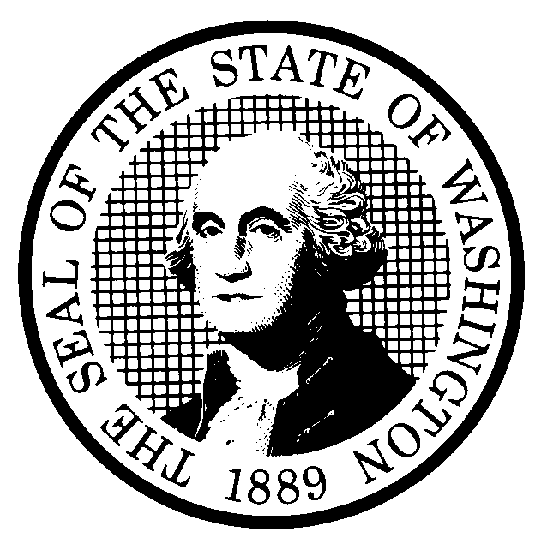  REVIEW OF PREVIOUSLY  ADOPTED RULES |  | CODE REVISER USE ONLY
CR-104 (February 2020)
(Implements RCW 34.05.630)
Agency:
Finding of Joint Administrative Rules Review Committee related to:

☐ Existing rule not within intent of legislature.
☐ Rule was not adopted in accordance with all applicable provisions of law.
☐ Agency is using policy or interpretive statements, guidelines, or documents in place of a rule.

Hearing on committee’s finding will be held:

Date:
Time:
Location:

Statement of committee’s findings and reasons:
Other agency comments or information:
Date:  Name:  Title: | Signature:  Place signature here

